INCRESE NIGERIA

Cesnabmihilo Dorothy Aken’Ova [ASHOKA fellow]
Position: Executive Director
Qualification: MA French
E-mail: darlyndotty@yahoo.co.uk
Website: http://increse-increse.org/

Background

The culture of silence on issues of sexuality and reproduction cuts across all cultures in Nigeria ; in some more than others. The majority of Nigerian people appear to be uncomfortable in discussing issues relating to sexuality and reproduction. This has resulted in poor or abject lack of information on sexual and reproductive health and rights among Nigerians, including policy makers at all levels.
These tendencies continue to gain grounds as a result of international campaigns by conservatives and fundamentalists bastardizing the terms “Sexual and Reproductive Rights”. They have continued to frustrate efforts to put global policies on sexual and reproductive rights in place, which could be used at country-level to improve Sexual and Reproductive Health. These campaigns have reinforced a negative and sometimes – confrontational attitudes, among Nigerians towards information/education on Sexual and Reproductive Health and Rights, with devastating effects, especially on vulnerable groups which include adolescents, women, people with disabilities and sexual minorities.
The denial of the importance of and necessity for Sexual and Reproductive Rights, lack of laws, policies, infrastructure and the political will to address Reproductive and sexual Health needs continue to have devastating effects on Nigerians. These include among others, the high rate of HIV/AIDS transmission and sexually Transmitted Diseases (STDs) among young people, maternal mortality and morbidity from unsafe abortions and lack of quality maternal care and sexual Violence. Addressing these call for immediate action.

- GOALS:
The International Centre for Reproductive Health and Sexual Rights - INCRESE, is a non-governmental, not-for-profit Organization, founded with the aim of creating an enabling environment for expanded access to Sexual Reproductive Health and Rights Information and Services.

- OBJECTIVES:

To Promote Sexual and Reproductive Rights at the national, regional and international levels.
To provide sexual and reproductive health services to women, adolescents and sexual minorities.
To promote pleasurable sex and safer-sex behaviour among community members.
To set up support mechanisms for people living under abusive conditions, especially people living with HIV/AIDS (PLWHAS) survivors of sexual violence and Sexual Minorities

VISION
Our vision is to always be the most preferred leading Sexual Health and Rights NGO.

MISSION
Our focus is to create an enabling environment for expanded access to Sexual Reproductive Health and Rights information and services.

VALUES
AUTONOMY
DIVERSITY
INTEGRITY
CHOICE

INCRESE carries out the following activities:
1. Advocacy targeting policy makers at all levels community and religious leaders.
2. Annual capacity-building course in the area of sexual and reproductive rights for young women in particular.
3. Daily counseling and Behavioural Change Communication (BCC) ,information / Education communication sessions in the centre.
4. Periodic outreach activities to schools and communities.
5. Quarterly newsletter-“YOUTH IN FOCUS with articles articles in English
6. Consultancy service in Gender and Adolescent Sexual and Reproductive Health.

Ford Foundation Projects

INCRESE has received funding support from the Ford Foundation in its work on Sexual Diversity and Human Rights in Nigeria.
INCRESE pioneered a research(2007-2009) to generate a research based body of Knowledge for the purpose of breaking ice on sexual diversity, gender expressions and identities discourse in Nigeria, and this research was funded by the Ford Foundation.
The study was conducted in all six geo-political zones of the country.
The results of the research led to Ford Foundation funding the follow-up project which is currently being executed by INCRESE and its partners.

Hajara Usman Resource Center

INCRESE has a resource center named after the late feminist and Sexual rights activist Hajara Usman that houses a library of sexual and reproductive health materials. The Hajara Usman Resource center is freely accessible to the public. Young people, most especially young women and girls are encouraged to make the most use of this facility.
The Hajara Usman center is open Monday to Friday every week from 9am-5pm.
The materials in the resource center were donated by various charitable individuals and organizations.

NINE GIRLS WERE GRADUATED FROM THE HAJARA USMAN GIRLS SCHOLARSHIP PROGRAM
1st October 2011
The Hajara Usman Girls Scholarship Program of the International Centre for Sexual Reproductive Rights graduated 9 girls on October 1, 2011 in recognition of the vital role women needs to play in decision making in our communities. The program was designed to equip young girls from selected schools with leadership skills, HIV and also help them to identify and address gender concerns with the long term aim that these girls would grow to become leaders and take part in decision making.
The program which started in October 2010 was named after a renowned feminist; Hajara Usman who died In Amsterdam in September of 1998, after a brief illness, She joined women in Nigeria (WIN) in the mid 1980’s and was the national secretary for two terms. She is among the founders of the Women’s Studies Nigeria, founding member of Women Independence, Self-sufficiency and Economic Advancement, Coordinator of the Women and Laws Nigeria Project of the International Solidarity Network of Women living under Muslim laws.

Graduating Participants presenting a drama on early marriage
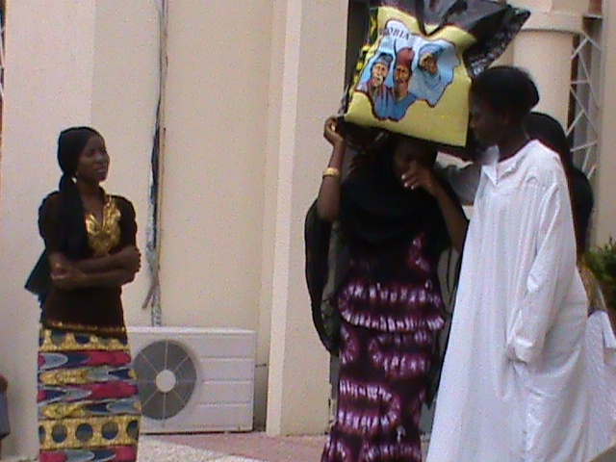

The Executive Director encouraging grandaunts to fully utilize the skills they have acquired
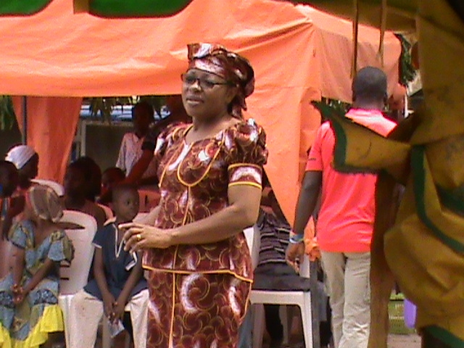

Presentation of certificate to a graduating participant
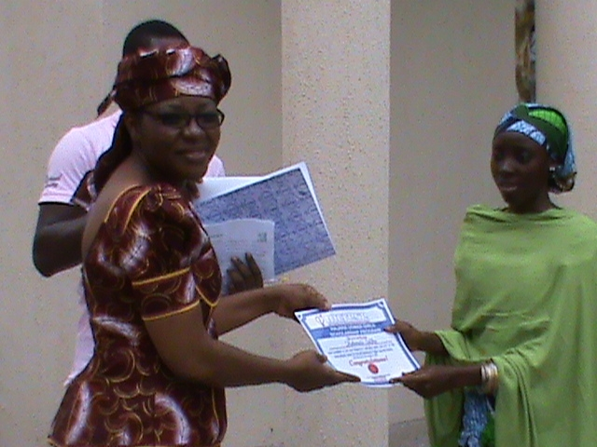

Graduating participants, Executive director, programme persons and peer educators
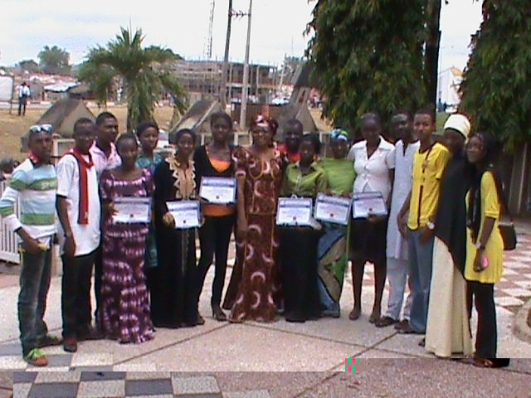

REPORTING GUIDE ON SEXUALITY
The culture of silence on issues of sexuality appears to cut across cultures in Nigeria. Research has shown that even in places where cultural practices may be perceived as liberal by others, silence on sexuality is even encouraged and protected. Majority of Nigerians have tended to be uncomfortable with discussing sex and sexuality and may not permit such topics to be freely discussed. Studies on human sexual behaviour in Nigeria reveal that there have been conscious efforts in many regions of the country to erase certain components of sexuality by prohibiting their discussions (Aken’Ova (1999 and 2000). This necessitates the media to act as the voice of the voiceless as it affects lesbians, gay, bi-sexual, transgender, Queer, Inter-sex (LGBTQIs) and other sexual minorities.
The Nigerian media have played a critical role in educating the general public on public health issues; however the media have an even bigger task explaining the many complex and unfolding issues relating to lesbians, gay, bi-sexual, transgender, Queer, Inter-sex (LGBTQIs) and other sexual minorities faced with discrimination in many areas of life, because of their sexual orientation and expression. In addition is the important task of using information to control and mitigate against impact of the discrimination faced by LGBTQIs.The mass media have been identified as an important tool in health intervention programs and it is almost impossible to find a community intervention program devoid of one or a combination of the following mass media channels and strategies: television, radio, newspapers, magazines, outdoor advertising, transit advertising, direct mail, telemarketing and other special promotional events. Therefore, the understanding of the imperativeness of the mass media provides the basis for the recognition of the role of the journalist in promoting awareness about key development issues including that relating to lesbians, gay, bi-sexual, transgender, Queer, Inter-sex (LGBTQIs) and other sexual minorities.
The role of the media is to serve as advocates in health education, health promotion and human rights promotion. The media also have it as part of their duty to ensure appropriate coverage of LGBTQIs issues as news, public service all aimed at increasing awareness and knowledge and promoting behaviour change and more so because lesbians, gay, bi-sexual, transgender, Queer, Inter-sex (LGBTQIs) and other sexual minorities rights are Human Rights.
The objective of the media tool kits is to build the capacity of journalists and therefore improve the mass media strategy to enhance reporting on sexual rights issues especially as they pertain to the LGBTQIs (lesbians, gays, bisexuals, transgender, Queer and inter-sex) communitie

Tool kits Objectives
The objective of this media tool kit is to serve as a guide in the process of equipping journalists for the onerous task of ‘creating’ a favourable environment for lesbians, gay, bi-sexual, transgender, Queer, Inter-sex (LGBTQIs) and other sexual minorities. While the media tool kit is for journalists to enhance reporting on sexual rights issues especially as they pertain to the LGBTQIs and other sexual minorities. The intended impact is also far reaching in that it is aimed at creating awareness to gain public support and acceptance.
The media understanding of the key issues as it affects LGBTQIs is very crucial to organizations working in the field and the community. Besides journalists other groups that would benefit from the outcome of the media tool kit include; health related NGOs including LEBTQIs activitists, human rights organisation, policy makers, community based organisation, traditional/local authorities, national government among others.
Some of the key objectives of the tool kit are:
· To educate journalists on the research on Sexual Diversity and Human Rights in Nigeria.
· To create a conducive and supportive policy for the LGBTQIs communities
· To erase barriers to understanding key issues within the LGBTQIs communities control engendered by misinformation and discrimination;
· Ensure that fundamental human rights of people are respected irrespective of their sexual orientation identity and expression
· To ensure sustenance of public support and goodwill.

